The moment of inertia was calculated for each dimension.

The moment of inertia is calculated from the combined moment of inertia for the following elements.

|  |
| --- |
| top wheel |
| fork |
| fork |
| junction |
| IMU |
| e-stop |
| power |
| power |
| converter |
| relay |
| breaker |
| controller |
| battery |
| battery |
| cRIO |
| column |
| junction |
| fork |
| fork |
| bottom wheel |

For the first dimension, all elements are modeled as a rectangle. The equation for the moment of inertia is

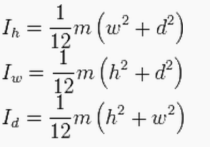

The first dimension is rotating about the d axis.

These equations are if you were rotating them about that axis through the center of the element. The axis of rotation does not run through most of our components. To calculate this value, we use the parallel axis theorem. The parallel axis theorem can determine the moment of inertia about any axis given the moment of inertia about a parallel axis through the elements center of mass and the perpendicular distance between the two axes.

In the case of 3d, r^2 has two dimensions to it, resulting in an absolute distance from the rotation axis. Many of our components are centered directly above the axis of rotation, so the third dimension is 0, but this is still accounted for in the calculation.

The rotation axis of the first dimension is about the axel of the lower motor. The rotation axis of the 2nd dimension is about the axis running along the length of the wheel where it contacts the ground.

